*Izgovori brojeve na engleskom jeziku:*

***2 5 7 9 11 15***

Posmatraj sliku i reci na engleskom jeziku:

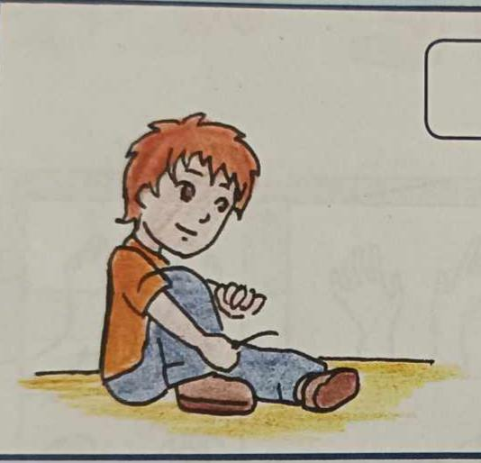 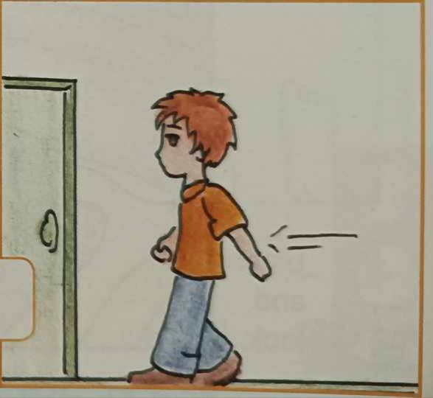

Put on your shoe. Go to the door.

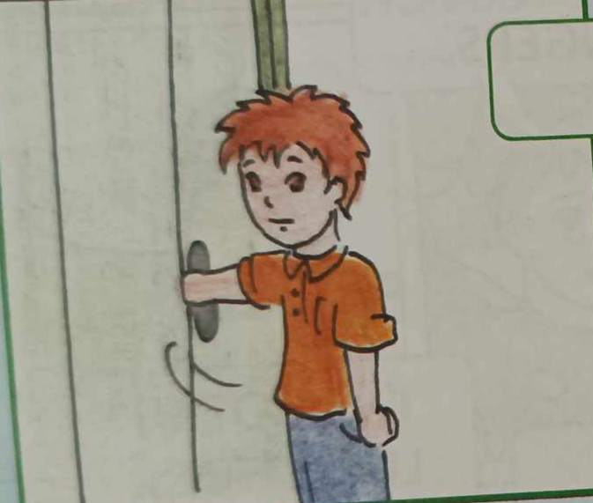 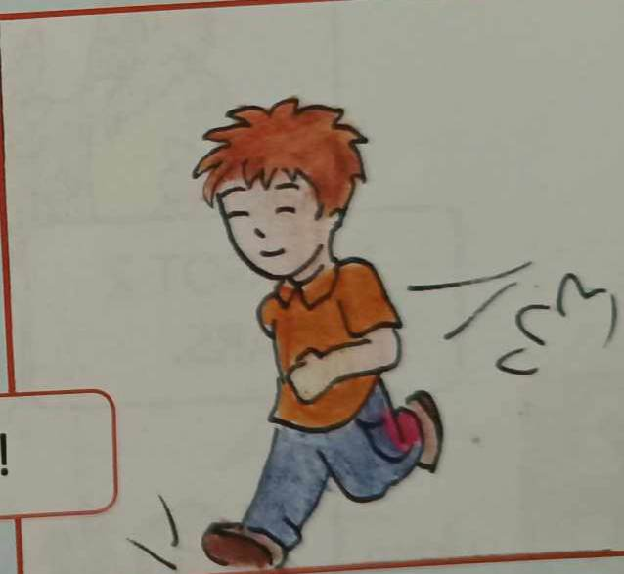

Open the door. Run! Don't wait!

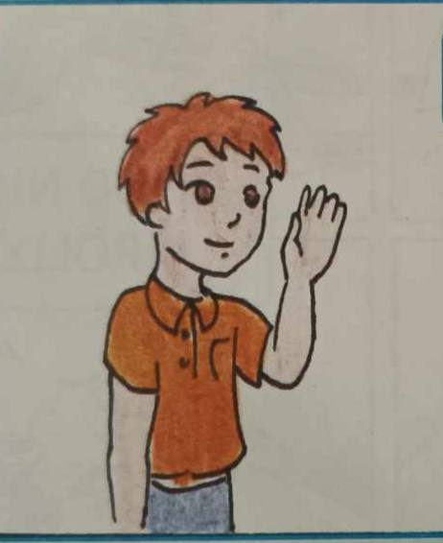 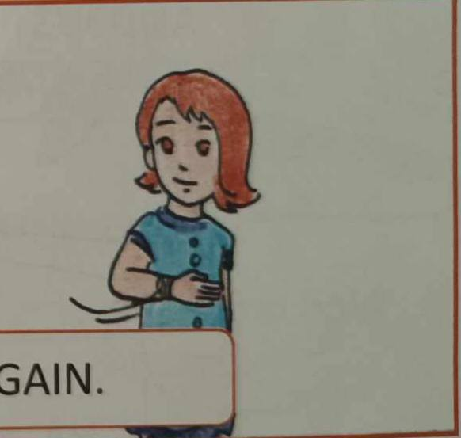

Goodbye my friend. Come again.